1. Control Flow

For loop: Control_Flow_for.m

Use “for” loop to compute pi and use a fixed number of random points, and compare the value as this number increases. Set n = 1000.

>> Control_Flow_for

Pi =

3.1400

While loop: Control_Flow_while.m

Define the precision into 1e-3, create a random number which is close to the given precision.

>> Control_Flow_while

pi_cal =

3.1413

**2、Plotting and formatted output.**

The two plotting is also in the files at the question one which is Control_Flow_for.m

And Control_Flow_while.m.

For loop:

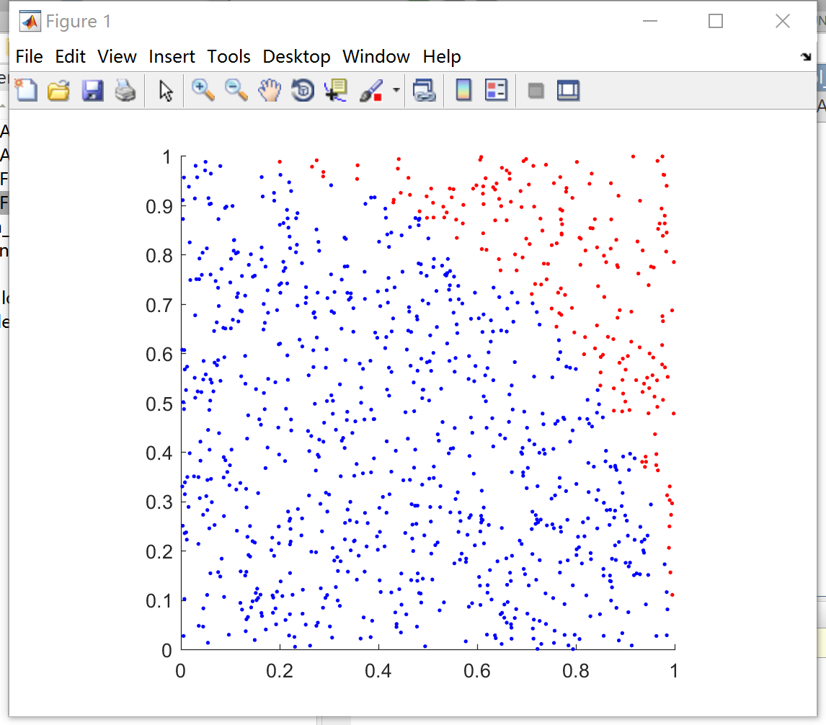

While loop:

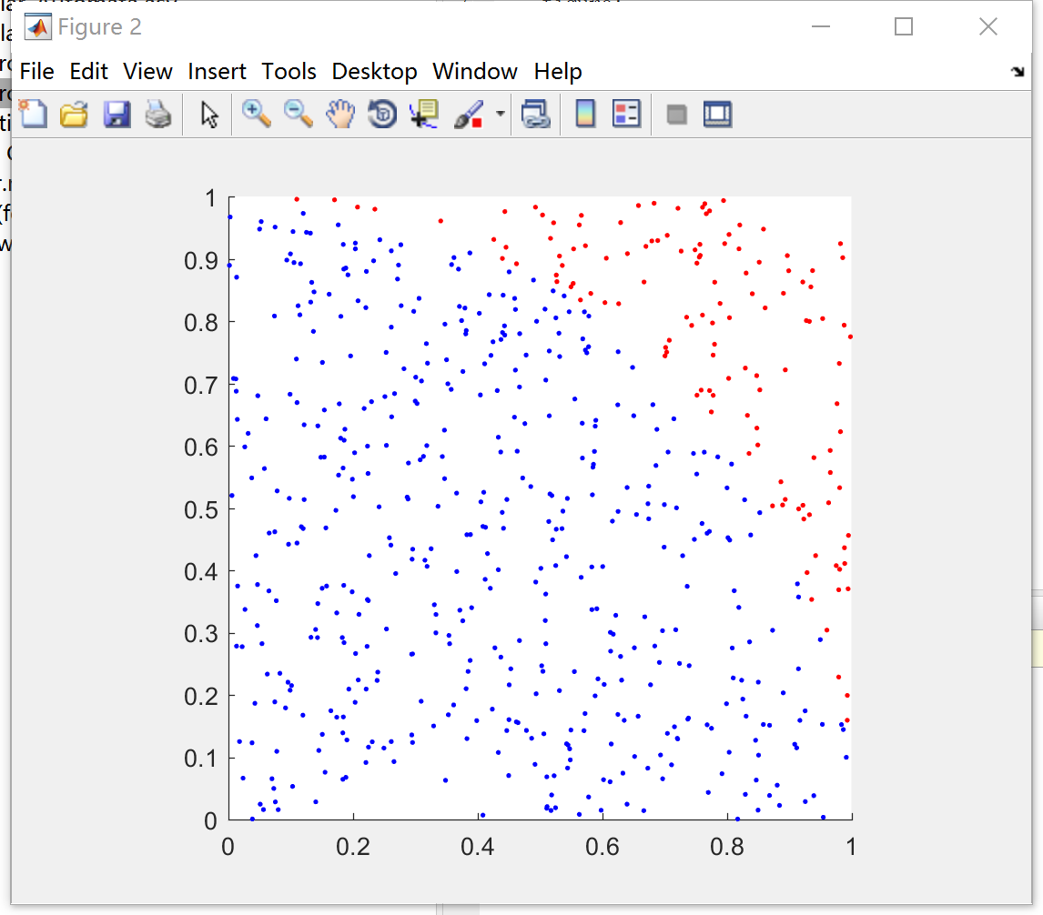

3、inner product

Inner.m

This function can check the input vectors and matrix are appropriately sized and give an error message if necessary.

4、Cellular Automata

Function_CA.m and Cellular_Automata